**Operating System Principles Prashanth.S**

**19MID0020**

**1) Study of basic linux commands**

1)ls

2) cd Desktop

3) pwd

3) cd ..

4) whoami

5) uname

6) ps

7) tty

8) date

9) history

10) who

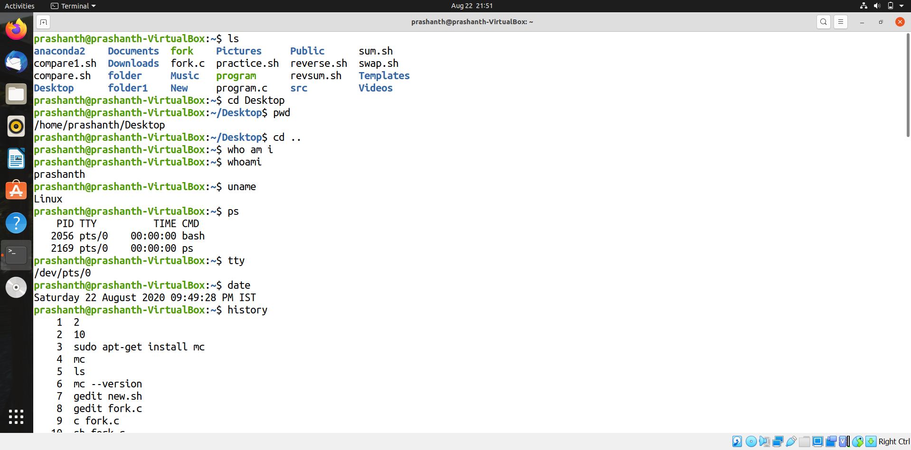

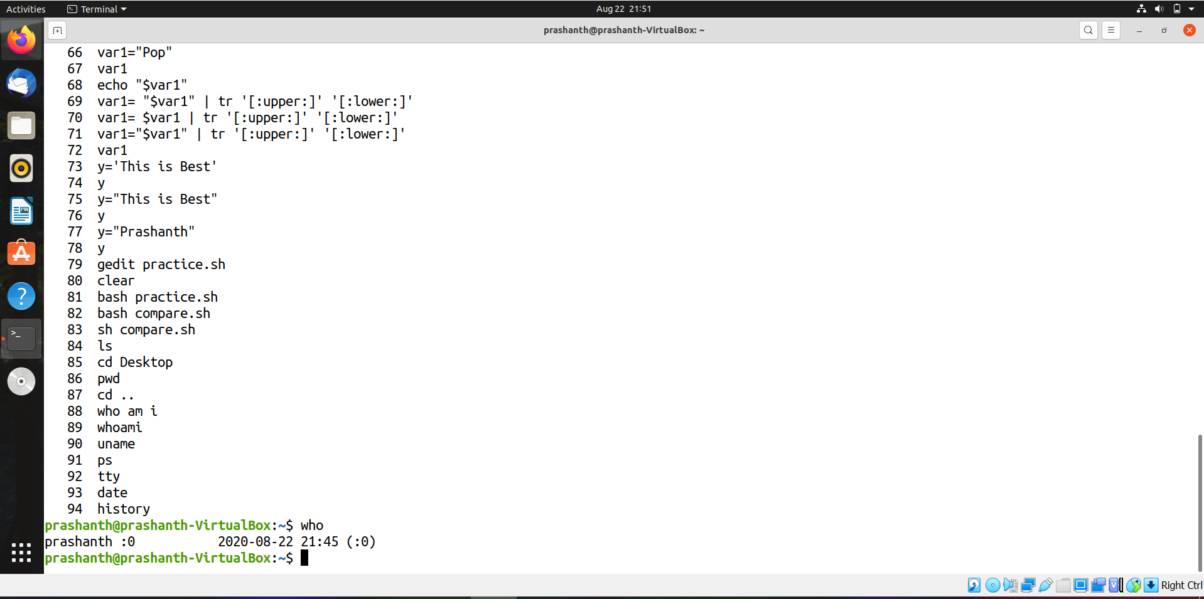

**2) Write a shell command two swap two numbers without using the third variable**



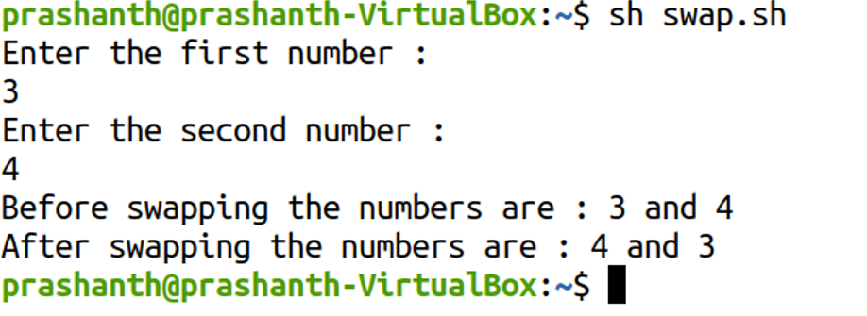

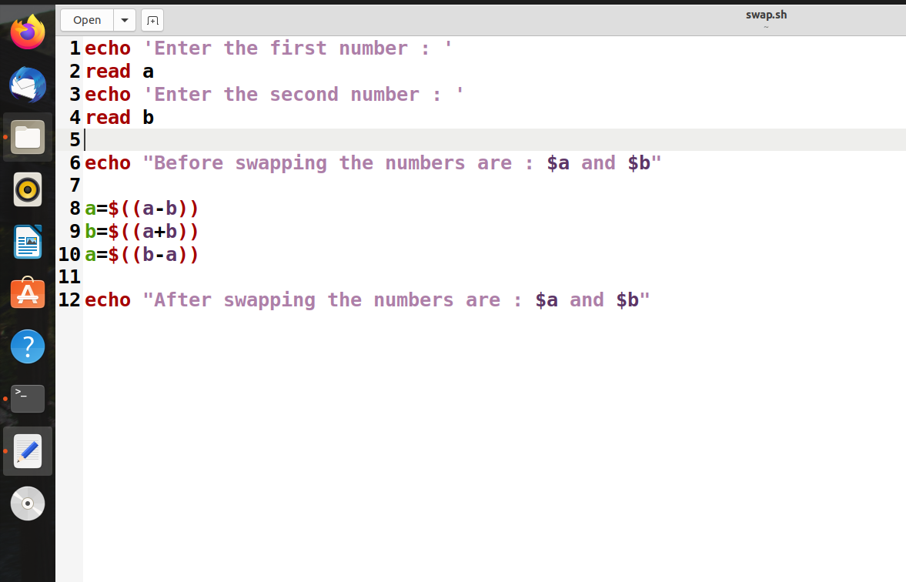

**3) Write the shell script using while loop to print the following structure**

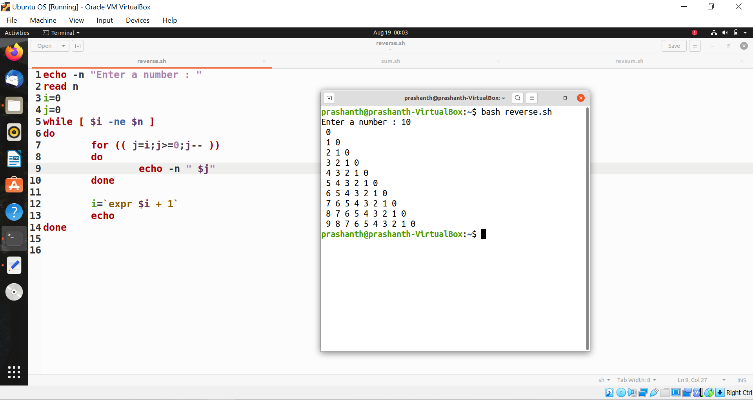

**4) Write the shell script to print the sum of first n natural numbers (use for loop)**

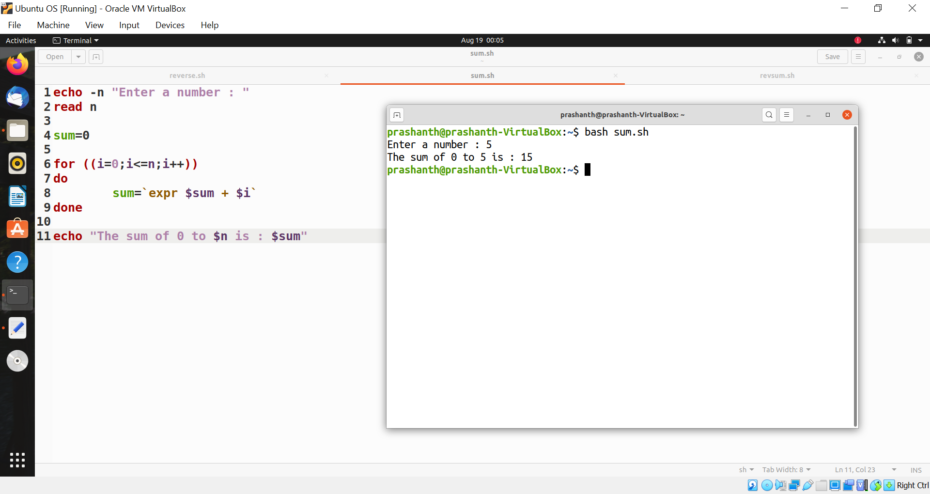

**5) Write a shell script to print the given number in reverse order and the sum of individual digits**

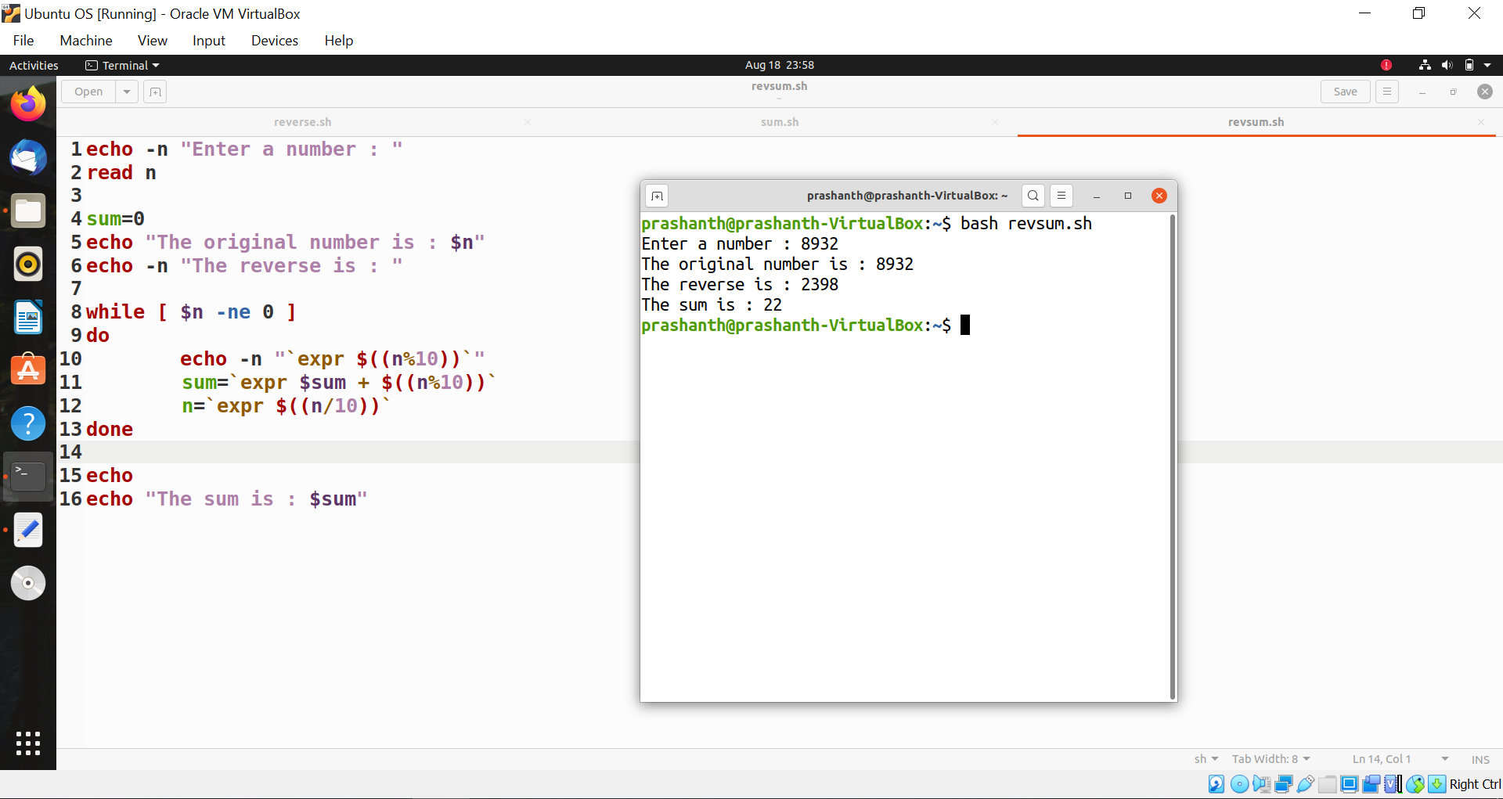

**6) Write a shell script to read two strings and display whether it is equal, not equal , null strings (or) string with special characters**

